Q1.
Answer is B.

A: Incorrect.
- @Component is used to tell Spring to automatically detect and register a class as a bean during component scanning.
- It creates a bean but it is not used to define a bean inside a configuration class.

B: Correct.
- @Bean is used inside a configuration class (@Configuration) to define a bean manually via a method.
- The method’s return object becomes a Spring bean.
- Used when you want full control over bean creation.
- Often used for third-party classes or complex setups

C: Incorrect.
- @Autowired is used for dependency injection, not for creating or defining beans.

D: Incorrect.
- @Service is a specialization of @Component. It marks a class as a service-layer bean.

Q2.
Answer is C.

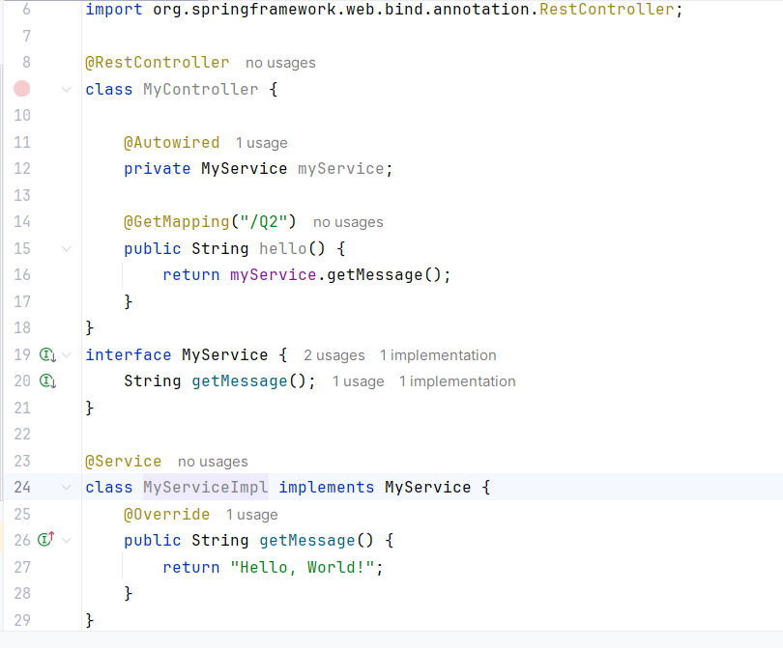

A: Incorrect. There is no missing bean.

B: Incorrect. Therefore myService will not be null.

C: Correct. Return a out put.

D: Incorrect. Spring registers the mapping and a 404 will not occur.

Q3.
Answer is D.

A: Spring creates beans only for classes annotated with: @Component, @Service, @Repository, @Controller, @RestController.
If the class is missing these annotations, Spring will not register it as a bean, so autowiring fails.

B: If you never tell Spring to inject the bean, it will not perform dependency injection.

C: @SpringBootApplication scans only: its own package and all subpackages
If your bean is located outside that package structure, Spring will not detect it.
Bean not detected, so autowiring fails.

D: All of the above are correct.

Q4.
Answer is C.

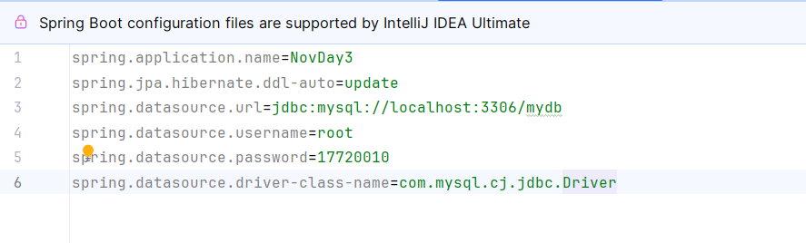

A: This creates a DriverManagerDataSource but it does not set URL, Username/Password and driver class.So, the datasource is not propely configured and cannot connect to a database.

B: There is no DataSource.builder() method in standard Java or Spring Boot.

C: Uses DataSourceBuilder provided by Spring Boot. Correctly sets URL, username, password. Builds a proper datasource.

D: DataSource is an interface, not a concrete class.

Q5.
Answer is B.

A: Handles exceptions locally in one controller only.

B: Correct. Provides global exception handling with @ExceptionHandler

C: There is no such annotation in Spring Framework or Spring Boot.

D: Incorrect. It only overrides Spring Boot’s built-in error page/path.

Q6.
Answer is A and C.

want to use constructor injection, which means:
Dependencies are provided to the class via its constructor.
Spring automatically injects the required beans when creating the object.

A: Using correct implementation of constructor injection. Spring will inject a Repository bean when creating MyService.

B: Incorrect. This is not constructor injection.

C: Uses a constructor to inject Repository.Spring automatically injects dependencies.

D: This is setter injection, not constructor injection.Dependencies are injected after object creation.

Q7.
Answer is B.

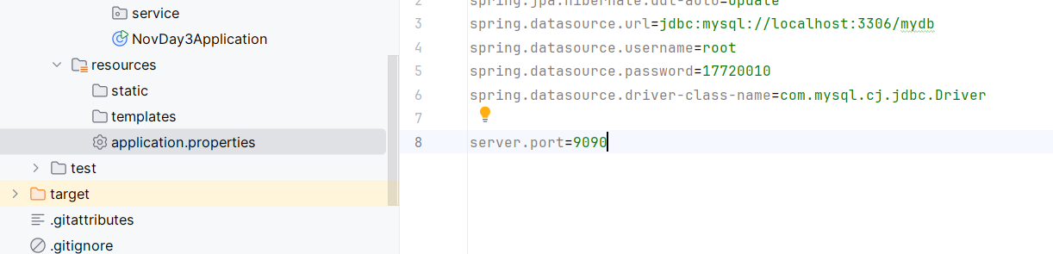

A: port=8080 .port alone is not recognized by Spring Boot.

B: server.port=8080 .Correct property key for configuring the server port in Spring Boot.

C: application.port is not a standard Spring Boot property.

D: spring.port is not recognized by Spring Boot.

Q8.
Answer is A.

A: Correct. Implements HealthIndicator, returns Health, annotated with @Component.

B: Incorrect. Spring Boot does not have @HealthCheck annotation.

C: Incorrect. Health is a final class in Spring Boot; you cannot extend it.

D: Returning a Health bean is not picked up automatically by Spring Boot

Q9.
Answer is A and C.

A: Correct potential cause. If your class is not in the base package, Spring will not detect it, and the bean will not be created.

B: No-args constructor is not required; Spring can use parameterized constructor.

C: Correct potential cause. If a class has no annotation, Spring will ignore it even if it’s in the correct package.

D: Incorrect. application.properties is optional.Bean creation does not depend on it.

Q10.
Answer is C.

A: Can listen to ApplicationReadyEvent and run code after context is ready.
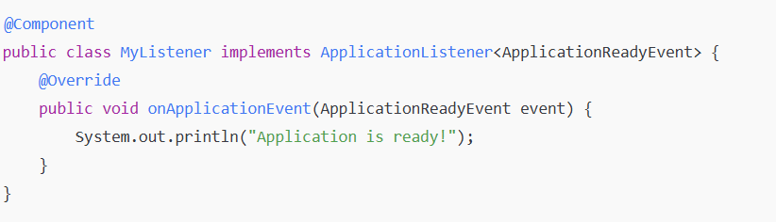

B: Incorrect. @PostConstruct runs a method after the bean has been initialized and its constructor executed.
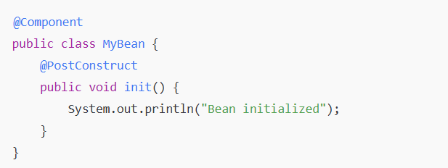

C: Correct. Implementing CommandLineRunner allows code to run after the entire ApplicationContext has been initialized. Runs once per application start.
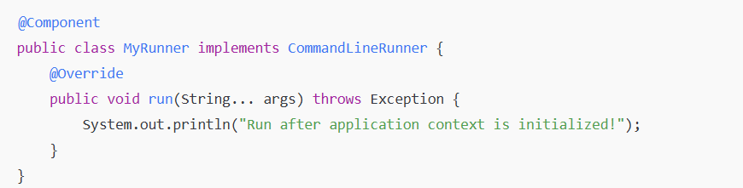

D: Incorrect. @Scheduled is for repeated tasks, not for running code exactly once.
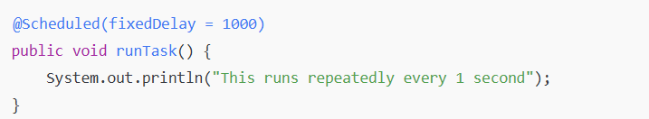
Q11.
Answer is D.

A: it causes code duplication because you have to write try-catch in every controller method.Not a global solution.
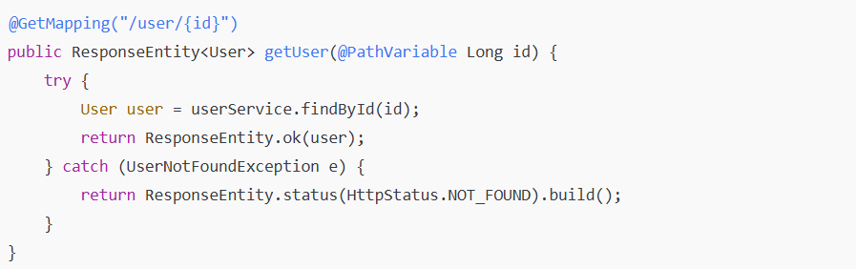

B: Custom error pages is not REST API standards.

C: still have to write exception handlers in each controller, causing code duplication. Not a global solution.
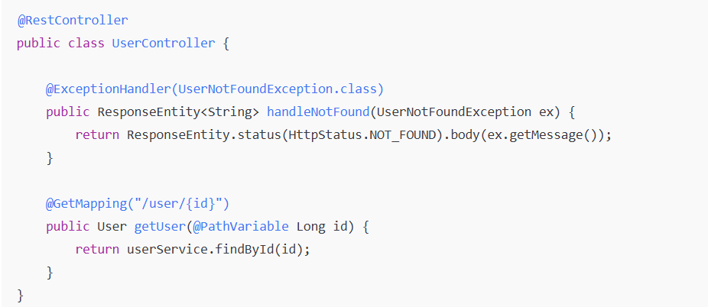

D: Correct @ControllerAdvice is a global exception handling class. @ExceptionHandler methods inside it handle exceptions for all controllers, not just one.Can easily customize HTTP status codes and JSON responses.
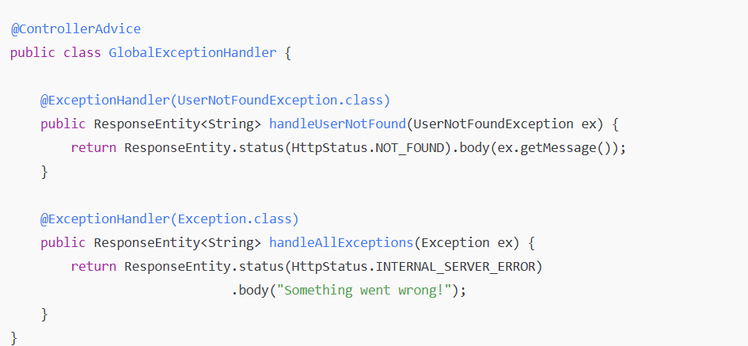

Q12.
Answer is A.

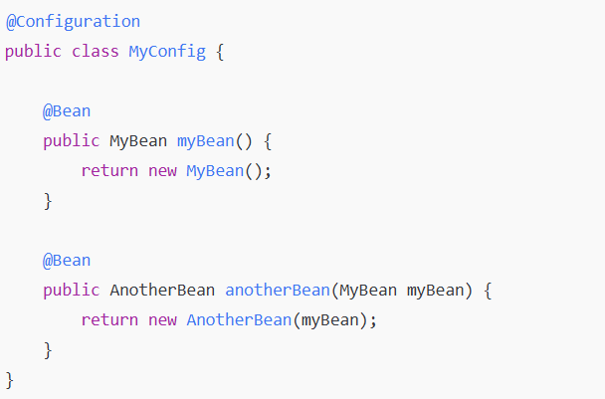
anotherBean(MyBean myBean) - Spring automatically injects the MyBean bean into the constructor of AnotherBean.

A: MyBean is passed as a parameter to the constructor of AnotherBean.

B: No setter method is used to inject dependencies.

C: No @Autowired field is present.

D: Method parameter is used, but the main pattern is constructor injection.

Q13.
Answer is A.

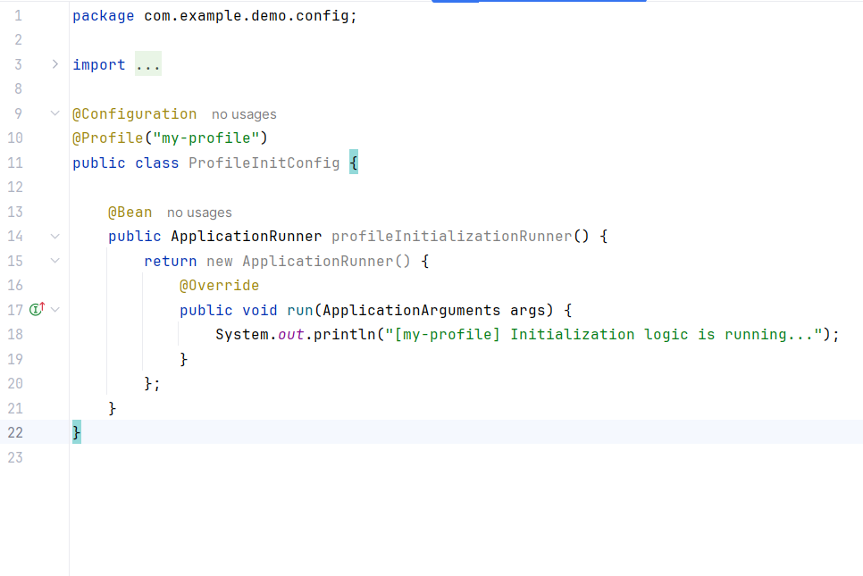

A: When the specified profile is active, spring loads and create the beans.

B: This checks properties, not profiles.

C: more complex and need to write extra code to check profiles.

D: Bean will still be created even if profile is not active.

Q14.
Answer is D.

A: Correct.
In Spring, each database connection needs a DataSource bean.
Can define multiple DataSource beans in a @Configuration class.

B: Correct.
When you have multiple DataSource beans, Spring needs to know which one is the default. You mark one bean as primary using @Primary.

C: Incorrect.
can define multiple datasource properties in application.properties, but still need a @Configuration class with @Bean definitions for each DataSource.

D: Both A and B are correct.

Q15.
Answer is A and B.

Aspect-Oriented Programming (AOP) allows you to separate cross-cutting concerns (like logging, security, transactions) from business logic. You can define aspects that execute before, after, or around method calls.
To use AOP in Spring Boot, you need:
-A dependency for AOP functionality.
-Enable AspectJ auto-proxying so Spring can recognize your aspect classes.
-Aspect classes annotated properly.

A: Correct. This annotation tells Spring to enable support for handling components marked with @Aspect. It allows Spring to automatically generate proxies for your beans that are targeted by aspects.

B: Correct. This dependency brings Spring AOP and AspectJ runtime into your project. Without it, the AOP functionality won't work.

C: Incorrect. Spring AOP does not require you to implement any interface named Aspect. Instead, you annotate your class with @Aspect.

D: Incorrect. @Configuration is for defining Spring beans via @Bean methods.

